Submitted by-Aditya Gautam

Roll No-12

M.sc. 3rd semester

Date of Assignment-03/11/2020

Date of Submission-10/11/2020

**Experiment No -04**

**Topic**- Tracing of Power curve for testing variance of a Normal Population**.**

**Problem** – A random sample of size 50 is drawn from a normal population with mean 9 and variance  ,where  is unknown.Draw the Power curves for testing : against

i) H1:>6 ii) H1: <6 iii) H1:6

Assume that,

**Theory and Calculation**-

Using Neyman’s pearson fundamental lemma, the critical region is given by-



Here,; , , 













(say)

Where,



**Case 1:**

When , then the C.R. is,



**Case 2:**

When , then the C.R. is,



**(i)**The C.R. for testing : against H1:>6 is given by



where k1 is a constant to be determined such that the size of the C.R. is equal to  ,

i.e., 











To find the value of k1,we use the following R-command :

a = qchisq(0.99,50,0) (0 is the non-centrality parameter)

This gives us the value 

 =76.15389 6=456.92334

Thus the C.R. is given by,



Now, the Power of the test is given by,

Power=1-β

=P{Reject H0|H1 is true}











Where, is the distribution function of the chi-square distribution with ‘n’ d.f.

Now to trace the power curve we consider different trial values of and construct the following table using R-Programming.

**Programming in R for case 1**

a = qchisq(0.99,50,0)

a

var = 6

k1 = var*a

k1

sigma1 = c(6.3,6.4,6.5,6.6,6.7,6.8,6.9,7.0,7.1,7.2,7.3,7.4,7.5,7.6,7.7,7.8,7.9,8.0,8.1,8.2,8.3,8.4,8.5,8.6,8.7,8.8,8.9,9.0,9.1,9.2)

sigma11 = k1/sigma1

power = mat.or.vec(30,1)

power1 = mat.or.vec(30,1)

for(i in 1:30){

power[i] = pchisq(sigma11[i],50,0)

power1[i] = 1-power[i]}

power1

plot(sigma1,power1)

**TABLE: 1**

|  |  |
| --- | --- |
| **Trial values of  (>6)** | **Power** |
| 6.3 | 0.02032695 |
| 6.4 | 0.02511999 |
| 6.5 | 0.03069667 |
| 6.6 | 0.03711564 |
| 6.7 | 0.04442920 |
| 6.8 | 0.05268202 |
| 6.9 | 0.06190997 |
| 7.0 | 0.07213921 |
| 7.1 | 0.08338554 |
| 7.2 | 0.09565397 |
| 7.3 | 0.10893859 |
| 7.4 | 0.12322264 |
| 7.5 | 0.13847889 |
| 7.6 | 0.15467016 |
| 7.7 | 0.17175003 |
| 7.8 | 0.18966377 |
| 7.9 | 0.20834932 |
| 8.0 | 0.22773833 |
| 8.1 | 0.24775739 |
| 8.2 | 0.26832909 |
| 8.3 | 0.28937324 |
| 8.4 | 0.31080797 |
| 8.5 | 0.33255078 |
| 8.6 | 0.35451955 |
| 8.7 | 0.37663348 |
| 8.8 | 0.39881386 |
| 8.9 | 0.42098483 |
| 9.0 | 0.44307400 |
| 9.1 | 0.46501294 |
| 9.2 | 0.48673762 |

**Power curve for case 1**

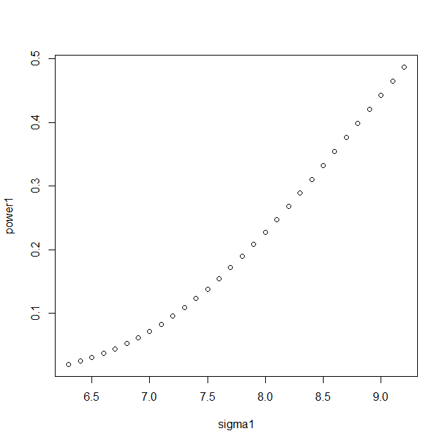

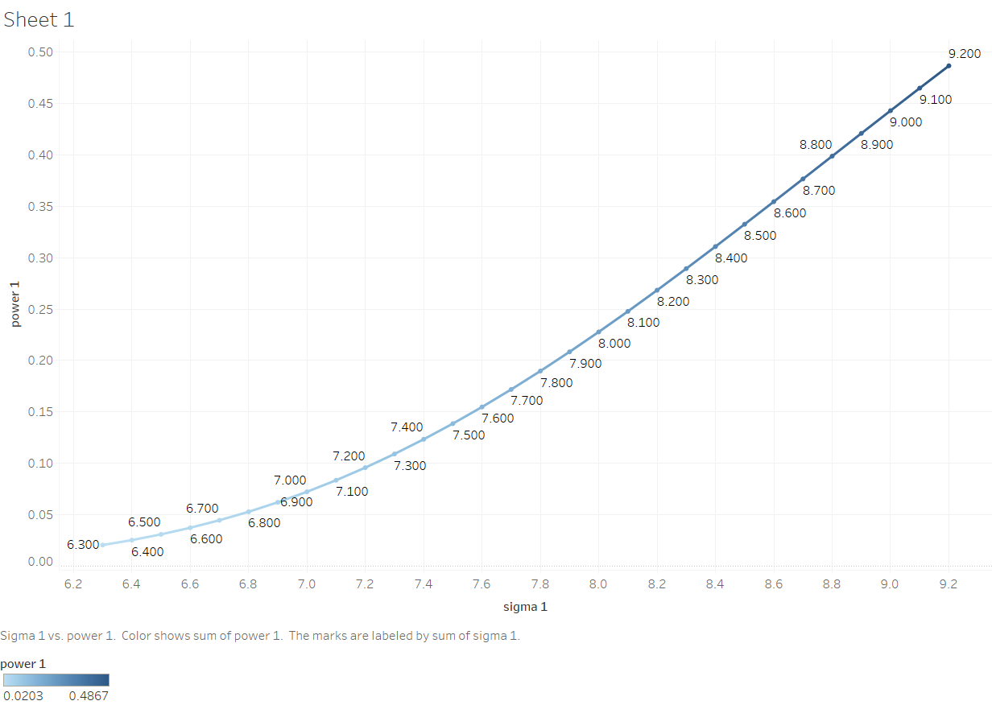

**(ii)**The C.R. for testing : against H1:<6 is given by



where k2 is a constant to be determined such that the size of the C.R. is equal to  ,

i.e., 







To find the value of k2,we use the following R-command :

a = qchisq(0.01,50,0) (0 is the non-centrality parameter)

This gives us the value  29.70668

= 2.706686=178.24008

Thus the C.R. is given by,



Now, the Power of the test is given by,

Power=1-β

=P{Reject H0|H1 is true}









Where, is the distribution function of the chi-square distribution with ‘n’ d.f.

Now to trace the power curve we consider different trial values of and construct the following table using R-Programming.

**Programming in R for case 2**

a = qchisq(0.01,50,0)

a

var = 6

k1 = var*a

k1

sigma1 = c(2.5,2.6,2.7,2.8,2.9,3.0,3.1,3.2,3.3,3.4,3.5,3.6,3.7,3.8,3.9,4.0,4.1,4.2,4.3,4.4,4.5,4.6,4.7,4.8,4.9,5.0,5.1,5.2,5.3,5.4)

sigma11 = k1/sigma1

power = mat.or.vec(30,1)

for(i in 1:30){

power[i] = pchisq(sigma11[i],50,0)}

power

plot(sigma1,power)

**TABLE: 2**

|  |  |
| --- | --- |
| **Trial values of  (<6)** | **Power** |
| 2.5 | 0.97442065 |
| 2.6 | 0.95822254 |
| 2.7 | 0.93597359 |
| 2.8 | 0.90714817 |
| 2.9 | 0.87166304 |
| 3.0 | 0.82989506 |
| 3.1 | 0.78263377 |
| 3.2 | 0.73098620 |
| 3.3 | 0.67625642 |
| 3.4 | 0.61982173 |
| 3.5 | 0.56302247 |
| 3.6 | 0.50707584 |
| 3.7 | 0.45301798 |
| 3.8 | 0.40167334 |
| 3.9 | 0.35364745 |
| 4.0 | 0.30933744 |
| 4.1 | 0.26895451 |
| 4.2 | 0.23255314 |
| 4.3 | 0.20006264 |
| 4.4 | 0.17131809 |
| 4.5 | 0.14608845 |
| 4.6 | 0.12410084 |
| 4.7 | 0.10506047 |
| 4.8 | 0.08866628 |
| 4.9 | 0.07462258 |
| 5.0 | 0.06264738 |
| 5.1 | 0.05247773 |
| 5.2 | 0.04387292 |
| 5.3 | 0.03661580 |
| 5.4 | 0.03051300 |

**Power curve for case 2**

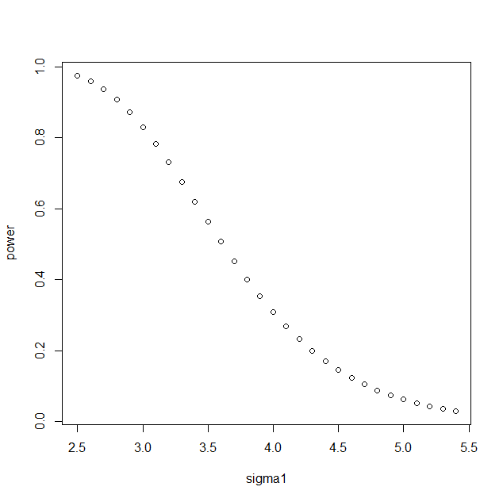

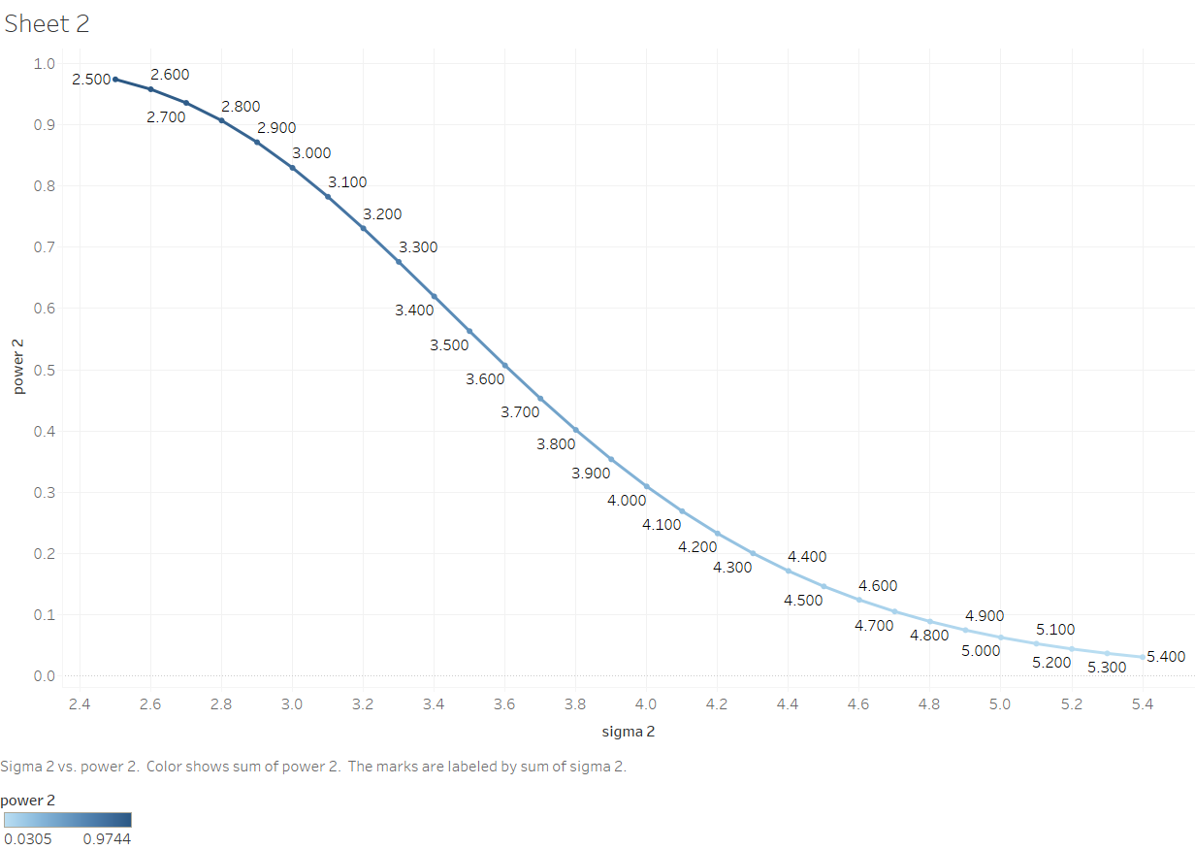

**(iii)**The C.R. for testing : against H1:6 is given by

W3={<k3 or  k4 }

where k3 and k4 are constants to be determined such that,



<k3 or  k4 |H0}=.01



Since, both are mutually exclusive

Assuming that the test is equitailed we have,







To calculate the value of c and d,we use the following R-command :

c = qchisq(0.005,50,0)

var = 6

k3 = var*c

d = qchisq(0.995,50,0)

var = 6

k4 = var*d





Thus the C.R. is given by,

W3={<167.9445 or  476.9399}

Now, the Power of the test is given by,

Power

<167.9445or  476.9399|H1 }





Now to trace the power curve we consider different trial values of and construct the following table using R-Programming.

**Programming in R for case 3**

c = qchisq(0.005,50,0)

d = qchisq(0.995,50,0)

var = 6

k3 = var*c

k4 = var*d

k3

k4

sigma1 = c(4.0,4.1,4.2,4.3,4.4,4.5,4.6,4.7,4.8,4.9,5.0,5.1,5.2,5.3,5.4,5.5,5.6,5.7,5.8,5.9,6.1,6.2,6.3,6.4,6.5,6.6,6.7,6.8,6.9,7.0,7.1,7.2,7.3,7.4,7.5,7.6,7.7,7.8,7.9,8.0)

sigma11 = k3/sigma1

sigma11

sigma22 = k4/sigma1

sigma22

power1 = mat.or.vec(40,1)

for(i in 1:40){

power1[i] = pchisq(sigma11[i],16,0)+(1-pchisq(sigma22[i],50,0))}

power1

plot(sigma1,power1)

**TABLE: 3**

|  |  |
| --- | --- |
| **Trial values of  (6)** | **Power** |
| 4.0 | 0.9996037 |
| 4.1 | 0.9994379 |
| 4.2 | 0.9992187 |
| 4.3 | 0.9989344 |
| 4.4 | 0.9985719 |
| 4.5 | 0.9981172 |
| 4.6 | 0.9975557 |
| 4.7 | 0.9968723 |
| 4.8 | 0.9960522 |
| 4.9 | 0.9950813 |
| 5.0 | 0.9939468 |
| 5.1 | 0.9926384 |
| 5.2 | 0.9911482 |
| 5.3 | 0.9894724 |
| 5.4 | 0.9876113 |
| 5.5 | 0.9855708 |
| 5.6 | 0.9833622 |
| 5.7 | 0.9810032 |
| 5.8 | 0.9785182 |
| 5.9 | 0.9759379 |
| 6.1 | 0.9706473 |
| 6.2 | 0.9680295 |
| 6.3 | 0.9655001 |
| 6.4 | 0.9631163 |
| 6.5 | 0.9609381 |
| 6.6 | 0.9590267 |
| 6.7 | 0.9574429 |
| 6.8 | 0.9562462 |
| 6.9 | 0.9554934 |
| 7.0 | 0.9552368 |
| 7.1 | 0.9555239 |
| 7.2 | 0.9563955 |
| 7.3 | 0.9578856 |
| 7.4 | 0.9600201 |
| 7.5 | 0.9628170 |
| 7.6 | 0.9662855 |
| 7.7 | 0.9704265 |
| 7.8 | 0.9752323 |
| 7.9 | 0.9806872 |
| 8.0 | 0.9867679 |

**power curve for case 3**

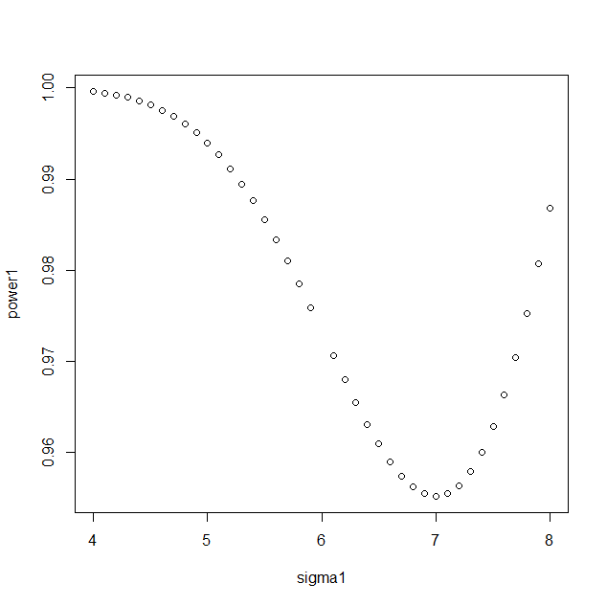

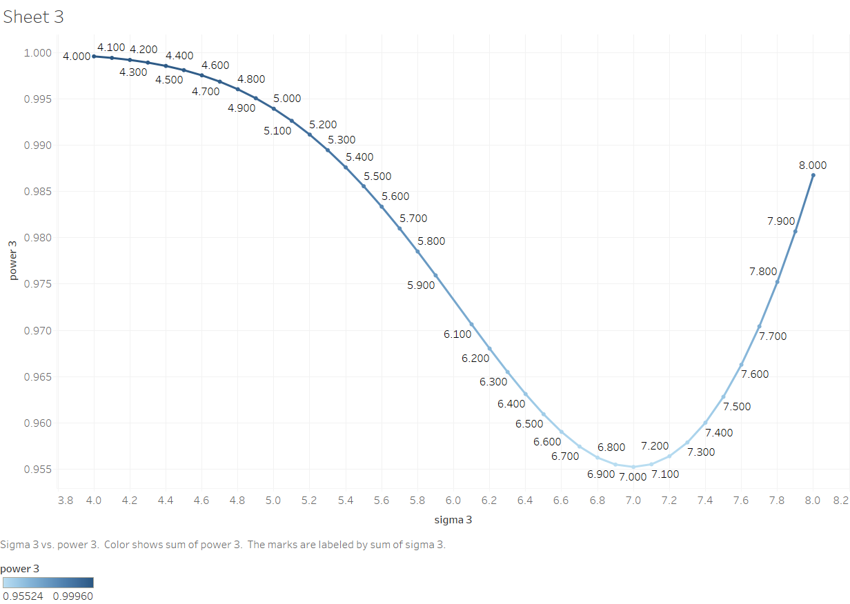

**Conclusion-**

Thus we get three different power curves for testing : against

i) H1:>6 ,ii) H1: <6 and iii) H1: respectively at the level of significance .